Teaching Report
The Faculty of Economics
Srinakharinwirot University
………………….

Lecturer name: xxxxxxx
Subject: ECOxxx xxxxxxxx

Session | Date | Day | Time | Hours | Topic | Evidence
1 | xxxx xx, 2022 | xxxx | xx.xx-xx.xx | 3 hours | xxxxxxxx | Attachment 1
2 | xxxx xx, 2022 | xxxx | xx.xx-xx.xx | 3 hours | xxxxxxxx | Attachment 2
3 | xxxx xx, 2022 | xxxx | xx.xx-xx.xx | 3 hours | xxxxxxxx | Attachment 3
4 | xxxx xx, 2022 | xxxx | xx.xx-xx.xx | 3 hours | xxxxxxxx | Attachment 4
5 | xxxx xx, 2022 | xxxx | xx.xx-xx.xx | 3 hours | xxxxxxxx | Attachment 5

Attachment 1
xxxx xx, 2022, xx.xx-xx.xx

v

Attachment 2
xxxx xx, 2022, xx.xx-xx.xx
v

Attachment 3
xxxx xx, 2022, xx.xx-xx.xx
v

Attachment 4
xxxx xx, 2022, xx.xx-xx.xx
v

Attachment 5
xxxx xx, 2022, xx.xx-xx.xx
v

EXAMPLE

Teaching Report
The Faculty of Economics
Srinakharinwirot University
………………….

Lecturer name: Assistant Professor Suppanunta Romprasert, Ph.D.
Subject: ECO712 ADVANCED MACROECONOMICS

Session | Date | Day | Time | Hours | Topic | Evidence
1 | January 10, 2022 | Monday | 09.30-12.30 | 3 hours | xxxxxxxx | Attachment 1
2 | January 17, 2022 | Monday | 09.30-12.30 | 3 hours | xxxxxxxx | Attachment 2

Attachment 1
January 10, 2022, 09.30-12.30

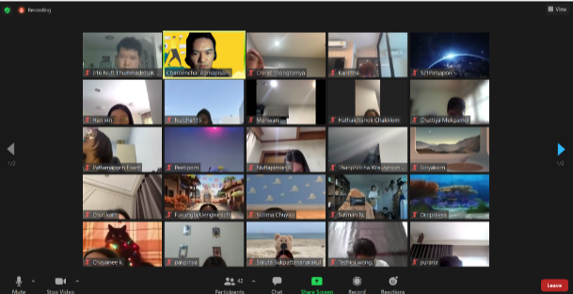
v
Student
Student
Student
Professor

Student
Student
Student
Professor

Student
Student
Student
Professor

Attachment 2
January 17, 2022, 09.30-12.30
v
Student
Student
Student
Professor

Student
Student
Student
Professor

Student
Student
Student
Professor

